Grade 7 Accelerated · Unit 3 · Thread A · Day 1  Exponent Laws with Variable Bases  Question Bank - Additional 3.T1 | Name______________________  Date______________________  Period____________________

Show your work. Circle your final answer.
For questions 1 through 6, write an equivalent expression as a single monomial. Assume no variable equals 0.
1. 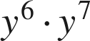

2. 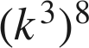

3. 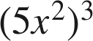

4. 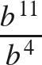

5. 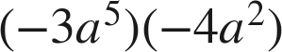

6. 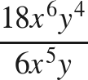

For questions 7 and 8, apply more than one law. Write each answer as a single monomial.
7. Write an equivalent expression.
a. 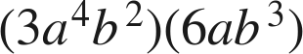

b. 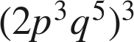

c. 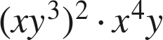

8. Write an equivalent expression.
a. 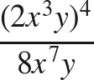

b. 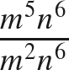

c. 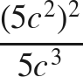

Working backwards.
9. Find the value of that makes each statement true.
a. 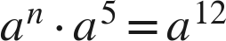

b. 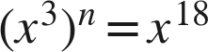

c. 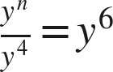

10. A rectangle has length 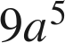 and width 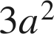.
a. Write its area as a single monomial.

b. A square has side length 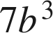. Write its area as a single monomial.

11. Which expression is equivalent to 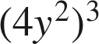 ?
○ A. 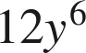
○ B. 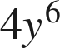
○ C. 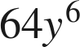
○ D. 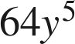

12. Select ALL of the expressions that are equivalent to 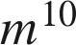.
□ A. 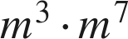
□ B. 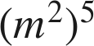
□ C. 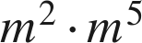
□ D. 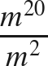
□ E. 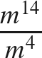
□ F. 